Award-winning Century 21 Gold have an exciting upcoming auction for a property that must sell.

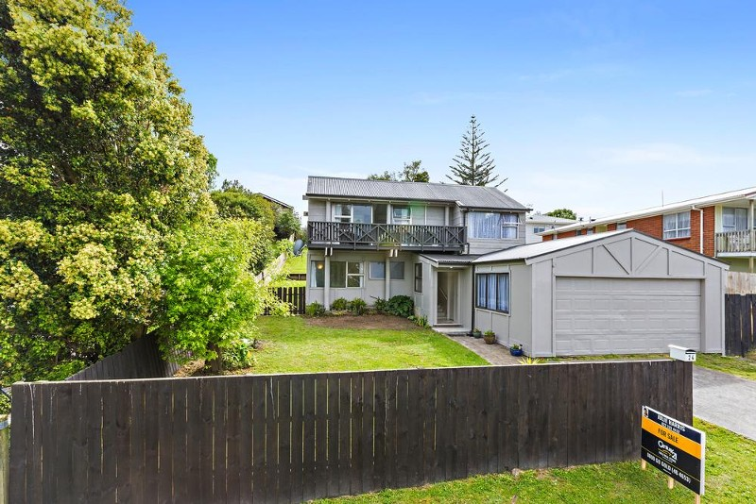
Mark your calendars for November 19 as that is when this awesome property at 24 Glenbervie Crescent, Massey, will be up for auction.
“A motivated vendor will meet the market because the plan to move is set in concrete,” says Julie Harris, Licensed Agent from Century 21 Gold Real Estate. Sitting on a spacious and fully fenced 695m2 Section, this home is centrally located in the Auckland suburb of Massey
This home is move in ready, “The interior has been freshly painted which enhances the spaciousness of the home with new carpet and vinyl throughout making it ready for you,” says Julie.
You will enjoy cooking and entertaining in the modern kitchen and dining area on the second floor. “This is a superb open plan living in this modern architecturally designed tri level home,” adds Julie.
A visit to this home is an absolute must! Your jaw will drop at the absolutely stunning views. “Panoramic views of the city night lights can be enjoyed from the home’s top level,” adds Julie.
A double garage and extra off street parking means you have plenty of room for the entire family to come over and check out your new home
Century 21 Gold Real Estate specialize in many Auckland areas including Weymouth, Central Manurewa, Manurewa East, Manurewa West, Manurewa South, Takanini, The Gardens, Wattle Downs, Papatoetoe, Mangere and Manukau.
Century 21 is an internationally recognized and respected business that is admired both worldwide and locally. The knowledge and expertise held by their highly trained staff makes them some of the best in the business. To make your home buying experience smooth and stress free choose Century 21 Gold.
If you are interested in bidding on this great property on the day and want to view the property or learn more about it get in contact with the team at Century 21 Gold and ask for real estate agent Julie Harris.
View the property online: http://www.century21.co.nz/property/417417/
Highlights of this beautiful home include:
- 3 Bedrooms
- Separate lounge top 3rd level
- Separate shower room
- Separate bath room
- Separate toilet
- Separate laundry
- Modern kitchen and Dining area on 2nd level
- Double garage, plus extra off-street parking
- Fully fenced 695m2 Section.
Auction Details:
Sun 19/11/2017 12:00 PM Onsite (unless sold prior by any means)
Inspection Times:
Sat 11/11/2017 11:00 AM to 12:00 PM
Sun 12/11/2017 11:00 AM to 12:00 PM

Contact Century 21 Gold Real Estate Manurewa:
Address: 25 Station Road Manurewa Auckland 2102
Postal Address: PO Box 75459 Manurewa Auckland 2243
Phone: 09 267 8980
Fax: 09 267 8982
Website: http://www.century21.co.nz/manurewa/
Facebook: https://www.facebook.com/Century-21-Gold-Real-Estate-212882935439686

Contact MediaPA:
Phone: 0274 587 724
Email: phillip@mediapa.co.nz
Website: www.mediapa.co.nz
Facebook: www.facebook.com/MediaPA
Twitter: www.twitter.com/NZ_MediaPA
YouTube: www.youtube.com/user/TheMediaPA
Pinterest: www.pinterest.com/NZMediaPA

