Century 21 Gold in Manurewa tips for attending an open home.
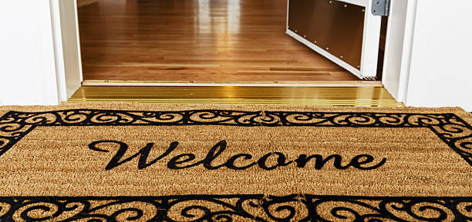
There’s an old saying that you should never judge a book by its cover and this is true for houses. Make sure you look past the perfectly placed furniture and staged décor and focus on whether the house would be a good fit for your wants and needs.
Here home buyer’s checklist of things you might have missed at first glance from the experts at Century 21.
Follow your nose
If you smell something ominous, it just could be. The faint odour of mildew might indicate the home was flooded, or it could be the sign of some sort of drainage or leak issue. “A musty odour can indicate water damage, even if you don’t see standing water,” says Derryn Mayne, Licensed Agent from Century 21 Gold Real Estate.
Layout and Storage Space
Pay special attention to the layout of the house and whether or not it works for your lifestyle. Ask yourself: will this space meet our needs in the long term? Is it spacious enough? Also look at the home’s storage space and whether it accommodate all your stuff? “Also look for closet placement and that the storage is in a convenient location,” advises Derryn
Look at the neighbourhood
Going to an open house should not only be about viewing the home itself. Make sure you have a critical eye for nearby homes and the location the house resides in. “You can also talk with other people that live in the area so that you can get a better idea of what it would be like to live in the neighbourhood,” comments Derryn.
Natural Light and Fresh Air
Take note of the time of day and how the house might feel when and where you want the sun. Not only is sunlight and fresh air enjoyable, but opening those windows and catching a breeze can help cut down on utility bills during those mid-summer months.

About Century 21 Gold:
Century 21 Gold Real Estate Manurewa offers its clients a full range of residential and rural services as well as Property Management. So for whatever your real-estate needs, contact the team at Century 21 Gold.

Contact Century 21 Gold Real Estate Manurewa:
Address: 25 Station Road Manurewa Auckland 2102
Postal Address: PO Box 75459 Manurewa Auckland 2243
Phone: 09 267 8980
Fax: 09 267 8982
Website: http://www.century21.co.nz/manurewa/
Facebook: https://www.facebook.com/Century-21-Gold-Real-Estate-212882935439686

Contact MediaPA:
Phone: 0274 587 724
Email: phillip@mediapa.co.nz
Website: www.mediapa.co.nz
Facebook: www.facebook.com/MediaPA
Twitter: twitter.com/NZ_MediaPA
YouTube: www.youtube.com/user/TheMediaPA
Pinterest: www.pinterest.com/NZMediaPA

