Lower the deposit requirements for moving into a new home says Century 21 Gold in Manurewa.

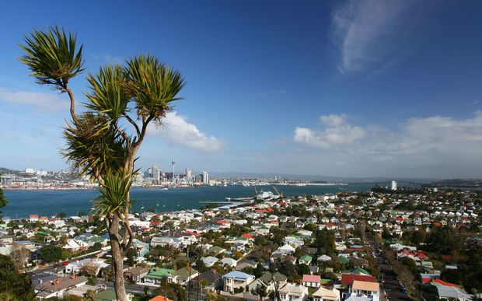
The calls to remove the 20 per cent deposits for first-home buyers, should be extended to more than just first-time buyers, says leading real estate expert, Derryn Mayne, Licensed Agent from Century 21 Gold Real Estate.
“Maybe we should be taking it further than just the first home buyers. What about the second and third home buyers who purchased when the market was at it’s peak?,” asks Derryn Mayne.
With the current high cost of living in Auckland it’s a struggle to save a big deposit. “They’re selling to move closer to work, or closer to schooling and don’t have enough deposit to meet the banks criteria, therefore are forced to stay in the first house they bought,” says Derryn.
Derryn believes that we should be making it easier for them to move up the ladder which in turn will free up properties for the first home buyers. “We should be supporting all New Zealanders who want to buy a home to live in,” says Derryn.
In Auckland, it currently takes a whopping $200,000 in deposit just to buy the average home.
“Most purchasers are double income earners who have the funds to support a mortgage – so why aren’t we giving them that opportunity?,” comments Derryn
There has also been calls for a review of loan-to-value restrictions imposed by the Reserve Bank of New Zealand two years ago.
“The Kiwi dream of owning your own ¼ acre property has gone by the wayside, but the dream is still there to purchase a home and the banks need to make it doable for this to happen,” adds Derryn.
Derryn Mayne and her expert team at Century 21 Gold have helped countless people get onto the property ladder. If you are taking your first steps onto the property ladder or are looking to move, contact the professional and friendly team at Century 21 Gold.
About Century 21 Gold:
Century 21 Gold Real Estate Manurewa offers its clients a full range of residential and rural services as well as Property Management. So for whatever your real-estate needs, contact the team at Century 21 Gold.

Contact Century 21 Gold Real Estate Manurewa:
Address: 25 Station Road Manurewa Auckland 2102
Postal Address: PO Box 75459 Manurewa Auckland 2243
Phone: 09 267 8980
Fax: 09 267 8982
Website: http://www.century21.co.nz/manurewa/
Facebook: https://www.facebook.com/Century-21-Gold-Real-Estate-212882935439686

Contact MediaPA:
Phone: 0274 587 724
Email: phillip@mediapa.co.nz
Website: www.mediapa.co.nz
Facebook: www.facebook.com/MediaPA
Twitter: twitter.com/NZ_MediaPA
YouTube: www.youtube.com/user/TheMediaPA
Pinterest: www.pinterest.com/NZMediaPA

