Sell your home this spring with leading real estate experts Century 21 Gold.

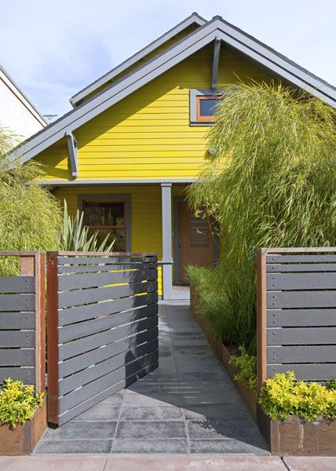
The beginning of spring marks the beginning of the busiest home-selling and home-buying season. The warmer weather means more daylight, so buyers are more likely to shop during this time of year. The real estate professionals from Century 21 Gold in Manurewa have expert tips for selling your home this spring.
Spring clean
First things first, give your home a good spring clean. While the light is very lovely in sprin its brightness can highlight less-than-clean surfaces. Polish your tap ware, remove cobwebs, wash your windows inside and out and dust your blinds. Take the time to polish your floors, mirrors and glass as clean reflective surfaces make a space feel larger.
A Blooming Garden
A beautiful garden will always bring the buyers in as they often fantasize about enjoying their backyards by entertaining and spending time outside. Try planting flowers in front of the house, have inside flower boxes, fresh paint, tidy landscaping and even outdoor furniture. “The gardens being in bloom and the beautiful clear blue skies make for some great marketing photos,” says Derryn.
Fresh Paint
Builder white and beige look dated with warm neutrals such as soft gray or pale taupe are preferred. Potential new owners need to imagine their life and belongings in the home without being overwhelmed by your design and colours.
Little Details
Matching pillowcases, a stack of neatly rolled towels in every bathroom and a laid-out dining setting can make home buyers feel more at home in your home. “Or rent furniture, accessories and artwork, to create a stylish feel inside that lures potential buyers,” advises Derryn.

About Century 21 Gold:
Century 21 Gold Real Estate Manurewa offers its clients a full range of residential and rural services as well as Property Management. So for whatever your real-estate needs, contact the team at Century 21 Gold.

Contact Century 21 Gold Real Estate Manurewa:
Address: 25 Station Road Manurewa Auckland 2102
Postal Address: PO Box 75459 Manurewa Auckland 2243
Phone: 09 267 8980
Fax: 09 267 8982
Website: http://www.century21.co.nz/manurewa/
Facebook: https://www.facebook.com/Century-21-Gold-Real-Estate-212882935439686

Contact MediaPA:
Phone: 0274 587 724
Email: phillip@mediapa.co.nz
Website: www.mediapa.co.nz
Facebook: www.facebook.com/MediaPA
Twitter: www.twitter.com/NZ_MediaPA
YouTube: www.youtube.com/user/TheMediaPA
Pinterest: www.pinterest.com/NZMediaPA

